Originator:
Name | Job Title | Signature | Date
Andrew Mason | Chief Technology Officer
Approvals:
Name | Job Title | Signature | Date
Brian Tompson | Software Engineer
Don Pegg | Senior Electrical Engineer
Andrea Miller | Quality Assurance Manager

- Purpose

This verification will assess the functionality of the new version R04.00.00 of the EPIC ClearView device firmware.

- Scope

This verification will document a verification of the ability for the firmware to be controlled by the application. Additionally the ability of the firmware to alter the image output will be challenged and documented. All requirements, to the extent they can be, will be individually tested to verify that they are satisfied.

- Responsibilities

EPIC staff is responsible for the execution of the protocol. QA is responsible to ensure that the verification is completed and that a report of the results is written. The CTO will be responsible to respond and/or investigate any deviations or discrepancies identified during the verification. Executive Management is responsible to ensure that the methods used accomplish the intended verification.

- Equipment

ClearView Software
ClearView Device (EPC-100)
Digital Multimeter Fluke 187 (or equivalent)
Oscilloscope Tektronix TDS 1002 (or equivalent)

- Procedure

Where applicable, the test will be performed using the currently released version of the ClearView software. The software has an administrative mode that allows the user to interact more directly with the firmware. This testing are can be found by logging in as either the ‘administrator’ user or the ‘techadministrator’ user and clicking on the ‘Settings’ icon and then on the ‘Device Testing’ tab.

A ClearView device containing the version of firmware to be tested should be connected to the computer system, the ClearView device is turned on and a calibration probe properly placed on the device before beginning this protocol.

ClearView Device Serial Number:
ClearView Computer System ID/Serial Number:
ClearView Software Version:
ClearView Firmware Version:
Digital Multimeter ID/Serial Number: Cal Date:
Oscilloscope ID/Serial Number: Cal Date:

  - [FRD_0005] Enable the settings of the pulse voltage through the use of a host command. Voltage level should be defaulted to a base level. The value specified for the voltage should be a % of the original value
Using the ClearView application, log in as the ‘administrator’ user and navigate to the ‘Device Testing’ tab on the ‘Settings’ page. Select the ‘Phillips’ camera from the drop down list at the top of the form. Press the ‘Connect to Device’ button to establish a connection to the device. Verify that the scanner is connected by looking at the live ‘Live Preview’ window to determine if a live preview is visible(you may need to lift up the calibration probe temporarily in order to verify this).

Verified Not Verified Non-Conformance Ref. No.

Once a connection has been established, check the check box next to the option ‘Write Settings on Image’ in the Other Options section of the page. Click the ‘LED Off’ button to verify that the LED is not on in the scanner by looking at the “Live Preview” window.

Verified Not Verified Non-Conformance Ref. No.

Click the ‘Begin Exposure’ button once and verify that an image is captured and that the voltage settings that appear in the ‘Boost Voltage’ drop down is reflected in the text on the captured image.

Verified Not Verified Non-Conformance Ref. No.

Change the voltage value in the ‘Boost Voltage’ drop down to ‘50% Power’ and click the ‘Begin Exposure’ button again. The image captured should be much dimmer than the captured in the step before and should have the voltage text on it of ‘50% Power’. Save the image labeled ENG0294150 (ENG-029 step 5.1, 50% power).

Verified Not Verified Non-Conformance Ref. No.

In the ‘Device Status’ group box, verify that the boost voltage reading is 63 +/- 3 volts

Verified Not Verified Non-Conformance Ref. No.

Change the voltage value in the ‘Boost Voltage’ drop down to ‘60% Power’ and click the ‘Begin Exposure’ button again. The image captured should be slightly brighter than the captured in the step before and should have the voltage text on it of ‘60% Power’. Save the image labeled ENG0294160 (ENG-029 step 5.1, 60% power).

Verified Not Verified Non-Conformance Ref. No.

In the ‘Device Status’ group box, verify that the boost voltage reading is 76 +/- 4volts.

Verified Not Verified Non-Conformance Ref. No.

Change the voltage value in the ‘Boost Voltage’ drop down to ‘70% Power’ and click the ‘Begin Exposure’ button again. The image captured should be slightly brighter than the captured in the step before and should have the voltage text on it of ‘70% Power’. Save the image labeled ENG0294170 (ENG-029 step 5.1, 70% power).

Verified Not Verified Non-Conformance Ref. No.

In the ‘Device Status’ group box, verify that the boost voltage reading is 88 +/- 4 volts.

Verified Not Verified Non-Conformance Ref. No.

Change the voltage value in the ‘Boost Voltage’ drop down to ‘80% Power’ and click the ‘Begin Exposure’ button again. The image captured should be much dimmer than the captured in the step before and should have the voltage text on it of ‘80% Power’. Save the image labeled ENG0294180 (ENG-029 step 5.1, 80% power).

Verified Not Verified Non-Conformance Ref. No.

In the ‘Device Status’ group box, verify that the boost voltage reading is 101 +/- 3 volts.

Verified Not Verified Non-Conformance Ref. No.

Change the voltage value in the ‘Boost Voltage’ drop down to ‘90% Power’ and click the ‘Begin Exposure’ button again. The image captured should be much dimmer than the captured in the step before and should have the voltage text on it of ‘90% Power’. Save the image labeled ENG0294190 (ENG-029 step 5.1, 90% power).

Verified Not Verified Non-Conformance Ref. No.

In the ‘Device Status’ group box, verify that the boost voltage reading is 113 +/- 2.3 volts.

Verified Not Verified Non-Conformance Ref. No.

Change the voltage value in the ‘Boost Voltage’ drop down to ‘100% Power’ and click the ‘Begin Exposure’ button again. The image captured should be much dimmer than the captured in the step before and should have the voltage text on it of ‘100% Power’. Save the image labeled ENG02941100 (ENG-029 step 5.1, 100% power).

Verified Not Verified Non-Conformance Ref. No.

In the ‘Device Status’ group box, verify that the boost voltage reading is 126 +/- 2.5 volts.

Verified Not Verified Non-Conformance Ref. No.

Change the voltage value in the ‘Boost Voltage’ drop down to ‘110% Power’ and click the ‘Begin Exposure’ button again. The image captured should be much dimmer than the captured in the step before and should have the voltage text on it of ‘110% Power’. Save the image labeled ENG02941110 (ENG-029 step 5.1, 110% power).
Verified Not Verified Non-Conformance Ref. No.

In the ‘Device Status’ group box, verify that the boost voltage reading is 139 +/- 2.8 volts.

Verified Not Verified Non-Conformance Ref. No.

Change the voltage value in the ‘Boost Voltage’ drop down to ‘120% Power’ and click the ‘Begin Exposure’ button again. The image captured should be much brighter than the captured in the step before and should have the voltage text on it of ‘120% Power’. Save the image labeled ENG02941120 (ENG-029 step 5.1, 120% power).
In the ‘Device Status’ group box, verify that the boost voltage reading is 151 +/- 4.5 volts.

Verified Not Verified Non-Conformance Ref. No.

Change the voltage value in the ‘Boost Voltage’ drop down to ‘100% Power’.

  - [FRD_0007] Enable the setting of the pulse duration through the use of a host command.

For the following sets of testing, the oscilloscope setup will be as follows:
Volts/Div: 1 V
Sec/Div: 100 ms/div
Trigger type: Edge
Trigger Source: Ch1
Trigger Slope: Falling
Trigger Mode: Normal
Trigger voltage: ~1.5 V
Connect the oscilloscope ground to TP7
Connect the oscilloscope probe to TP6.
Note: On the TDS-1002 oscilloscope ‘Peak Detect’ on the acquire menu must be turned on.
Change the value in the drop down labeled ‘Exposure Duration’ from the default value of ‘.5 Seconds’ to ‘1 Second’ and press the ‘Begin Exposure’ button. Verify that the system energizes for approximately 1 second.
Verified Not Verified Non-Conformance Ref. No.

Change the value in the drop down labeled ‘Exposure Duration’ from ‘1 Second’ to ’2 Seconds’ and press the ‘Begin Exposure’ button. Verify that the system energizes for approximately 2 seconds.
Verified Not Verified Non-Conformance Ref. No.

Change the value in the drop down labeled ‘Exposure Duration’ from ‘2 Seconds’ to ’30 Seconds’ and press the ‘Begin Exposure’ button. Verify that the system energizes for approximately 30 seconds.
Verified Not Verified Non-Conformance Ref. No.

Change the value in the drop down labeled ‘Exposure Duration’ from ‘30 Seconds’ to ’.5 Seconds’ and press the ‘Begin Exposure’ button. Verify that the system energizes for approximately .5 seconds.

Verified Not Verified Non-Conformance Ref. No.

  - [FRD_0008] Add a host command to control “Flood” LED output. The states are defined as on and off.
Press the ‘LED Off’ button even if the LED is already off. Press the ‘LED On’ button and verify that the LED is on and the light can be seen in the ‘Live Preview’ window.
Verified Not Verified Non-Conformance Ref. No.

Press the ‘LED Off’ button and verify that the LED is off and the light cannot be seen in the ‘Live Preview’ window.
Verified Not Verified Non-Conformance Ref. No.

  - [FRD_0009] Enable the PWM0 signal frequency to be controlled by a host command. There will be multiple frequency settings.
Change the PWM0 Frequency drop down from 1100Hz to the 750Hz option. Press the ‘Begin Exposure’ button, an image should be captured with 750Hz stamped on it and it should be a dimer image. (You may also notice a slightly lower frequency tone). Right click and select “Save” to save the image labeled ENG02954750 (ENG-029 step 5.4, 750Hz).

Verified Not Verified Non-Conformance Ref. No.

Verify that the frequency generated is 750Hz +/- 7.5Hz

Verified Not Verified Non-Conformance Ref. No.

Change the PWM0 Frequency drop down from 750Hz to the 800Hz option. Press the ‘Begin Exposure’ button, an image should be captured with 800Hz tamped on it and it should be a slightly brighter image. (You may also notice a slightly higher frequency tone). Right click and select “Save” to save the image labeled ENG02954800 (ENG-029 step 5.4, 800Hz).
Verified Not Verified Non-Conformance Ref. No.

Verify that the frequency generated is 800Hz +/- 8 Hz

Verified Not Verified Non-Conformance Ref. No.

Change the PWM0 Frequency drop down from 800Hz to the 850Hz option. Press the ‘Begin Exposure’ button, an image should be captured with 850Hz stamped on it and it should be a brighter image. (You may also notice a slightly higher frequency tone). Right click and select “Save” to save the image labeled ENG02954850 (ENG-029 step 5.4, 850Hz).
Verified Not Verified Non-Conformance Ref. No.

Verify that the frequency generated is 850Hz +/- 8.5 Hz

Verified Not Verified Non-Conformance Ref. No.

Change the PWM0 Frequency drop down from 850Hz to the 900Hz option. Press the ‘Begin Exposure’ button, an image should be captured with 900Hz stamped on it and it should be a brighter image. (You may also notice a slightly higher frequency tone). Right click and select “Save” to save the image labeled ENG02954900 (ENG-029 step 5.4, 900Hz).
Verified Not Verified Non-Conformance Ref. No.

Verify that the frequency generated is 900Hz +/- 9 Hz

Verified Not Verified Non-Conformance Ref. No.

Change the PWM0 Frequency drop down from 900Hz to the 950Hz option. Press the ‘Begin Exposure’ button, an image should be captured with 950Hz stamped on it and it should be a brighter image. (You may also notice a slightly higher frequency tone). Right click and select “Save” to save the image labeled ENG02954950 (ENG-029 step 5.4, 950Hz).
Verified Not Verified Non-Conformance Ref. No.

Verify that the frequency generated is 950Hz +/- 9.5 Hz

Verified Not Verified Non-Conformance Ref. No.

Change the PWM0 Frequency drop down from 950Hz to the 1000Hz option. Press the ‘Begin Exposure’ button, an image should be captured with 1000Hz stamped on it and it should be a brighter image. (You may also notice a slightly higher frequency tone). Right click and select “Save” to save the image labeled ENG029541000 (ENG-029 step 5.4, 1000Hz).
Verified Not Verified Non-Conformance Ref. No.

Verify that the frequency generated is 1000Hz +/- 10 Hz

Verified Not Verified Non-Conformance Ref. No.

Change the PWM0 Frequency drop down from 1000Hz to the 1050Hz option. Press the ‘Begin Exposure’ button, an image should be captured with 1050Hz stamped on it and it should be a brighter image. (You may also notice a slightly higher frequency tone). Right click and select “Save” to save the image labeled ENG029541050 (ENG-029 step 5.4, 1050Hz).
Verified Not Verified Non-Conformance Ref. No.

Verify that the frequency generated is 1050Hz +/- 10.5 Hz

Verified Not Verified Non-Conformance Ref. No.

Change the PWM0 Frequency drop down from 1050Hz to the 1100Hz option. Press the ‘Begin Exposure’ button, an image should be captured with 1100Hz stamped on it and it should be a brighter image. (You may also notice a slightly higher frequency tone). Right click and select “Save” to save the image labeled ENG029541100 (ENG-029 step 5.4, 1100Hz).
Verified Not Verified Non-Conformance Ref. No.

Verify that the frequency generated is 1100Hz +/- 11 Hz

Verified Not Verified Non-Conformance Ref. No.

Change the PWM0 Frequency drop down from 1100Hz to the 1150Hz option. Press the ‘Begin Exposure’ button, an image should be captured with 1150Hz stamped on it and it should be a brighter image. (You may also notice a slightly higher frequency tone). Right click and select “Save” to save the image labeled ENG029541150 (ENG-029 step 5.4, 1150Hz).
Verified Not Verified Non-Conformance Ref. No.

Verify that the frequency generated is 1150Hz +/- 11.5 Hz

Verified Not Verified Non-Conformance Ref. No.

Change the PWM0 Frequency drop down from 1150Hz to the 1200Hz option. Press the ‘Begin Exposure’ button, an image should be captured with 1200Hz stamped on it and it should be a brighter image. (You may also notice a slightly higher frequency tone). Right click and select “Save” to save the image labeled ENG029541200 (ENG-029 step 5.4, 1200Hz).
Verified Not Verified Non-Conformance Ref. No.

Verify that the frequency generated is 1200Hz +/- 12 Hz

Verified Not Verified Non-Conformance Ref. No.

Change the PWM0 Frequency drop down from 1200Hz to the 1100Hz option.

  - [FRD_0010] Add a host command to stop the pulse duration before the predefined time has completed. If the duration was set to 30 seconds, sending this command before 30 seconds would stop the pulse.
This test is meant to verify the firmware abort command works. All pulse durations (i.e., .5, 1, 2 and 30 second) will terminate in the same manner. Therefore, only the longest (30 second) pulse duration has been selected. Change the value in the drop down labeled ‘Exposure Duration’ from ’.5 Seconds’ to ’30 Seconds’ and press the ‘Begin Exposure’ button. Wait 5 seconds and then press the button labeled ‘Abort’. Verify that the system quickly stops the pulse.
Verified Not Verified Non-Conformance Ref. No.

Press the ‘Begin Exposure’ button again and verify that the exposure completes the full duration (approximately 30 seconds).
Verified Not Verified Non-Conformance Ref. No.

  - [FRD_0011] Add a host command to initialize the pulse; this would start the pulse for the selected duration.
Change the value in the drop down labeled ‘Exposure Duration’ from ’30 Seconds’ to ’.5 Seconds’ and press the ‘Begin Exposure’ button. Verify that the system energizes and an image is captured.
Verified Not Verified Non-Conformance Ref. No.

  - [FRD_0014] Implement a two-way communications protocol between the host computer and the device.
Click the ‘Clear Log’ link that appears below the information log box, this should clear out the information log. Press the ‘LED On’ button and view the debug log window that appears below the Live Preview window. Verify that for each command that is issued there is a ‘Received’ line. An example is shown below:
Verified Not Verified Non-Conformance Ref. No.

  - [FRD_0016] Implement a host command that will return the current settings of the device, including version number.
Press the ‘Get Information’ button and verify the following:.
- The PWM0 Frequency under Device Settings matches the PWM0 Frequency listed in the Device Status box and matches the value displayed in the information log box. See Figure 1 below for an example (the values will not be the same during testing, this is an example only).
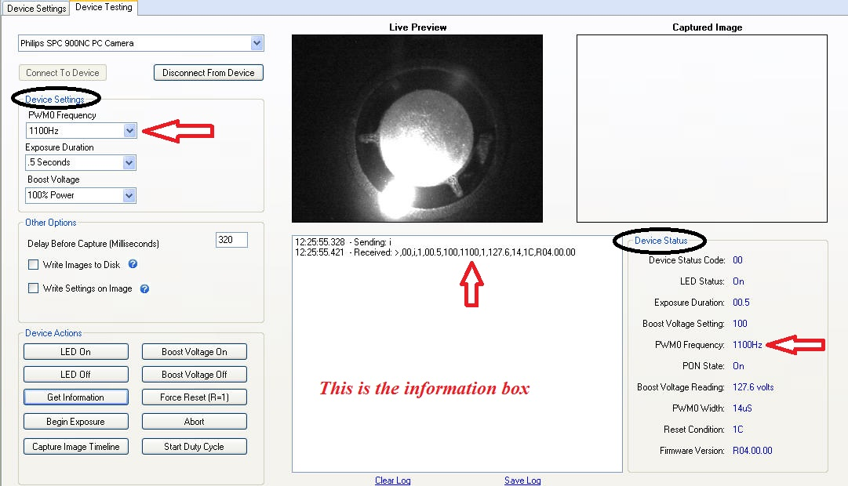
Figure 1

Verified Not Verified Non-Conformance Ref. No.

- Verify the Device Status Code displayed under Device Status matches the value displayed in the information log box (first value displayed after the >).

Verified Not Verified Non-Conformance Ref. No.

- Click the Clear Log button under the information box. Click the LED On button under the Device Actions section. Click the Get Information button in the Device Actions section. Verify that the LED Status in the Device Status box is “On” and the LED light is on in the Live Preview window display.

Verified Not Verified Non-Conformance Ref. No.

- Click the Clear Log button under the information box. Click the LED Off button under the Device Actions section. Click the Get Information button in the Device Actions section. Verify that the LED Status in the Device Status box is “Off” and the LED light is not on in the Live Preview window display.

Verified Not Verified Non-Conformance Ref. No.
- Verify the Exposure Duration under Device Settings matches the Exposure listed in the Device Status box and matches the value displayed in the information log box(fourth value displayed after the >).

Verified Not Verified Non-Conformance Ref. No.

- Verify that the Boost Voltage Setting under Device Settings matches the Boost Voltage Setting listed in the Device Status box and matches the value displayed in the information log box (fifth value displayed after the >).

Verified Not Verified Non-Conformance Ref. No.

- Verify the PON State displayed under Device Status matches the value displayed in the information log box (seventh value displayed after the >). Note: On = 1 and Off = 0.

Verified Not Verified Non-Conformance Ref. No.

- Verify the Boost Voltage Reading displayed under Device Status matches the value displayed in the information log box (eighth value displayed after the >).

Verified Not Verified Non-Conformance Ref. No.

- Verify the PWM0 Width is displayed as 14us under Device Status and matches the value displayed in the information log box (ninth value displayed after the >).

Verified Not Verified Non-Conformance Ref. No.

- Verify the Reset Condition displayed under Device Status and matches the value displayed in the information log box (tenth value displayed after the >).

Verified Not Verified Non-Conformance Ref. No.

- Verify the Firmware Version displayed under Device Status and matches the value displayed in the information log box (eleventh value displayed after the >, also the last value displayed in the information box).

Verified Not Verified Non-Conformance Ref. No.

  - [FRD_0025] Diagnostics mode will allow testing during the manufacturing process.
This requirement cannot be completely tested through the application as not all of the debug commands have been exposed in the ‘Device Testing’ interface. Further testing will be done at the firmware and device level to verify that the functionality is properly implemented.
Press the ‘Get Information’ button and verify that the information command was sent to the unit and that a response was received from the device, the output should look like the following:
Click the Boost Voltage On button in the Device Actions section. Look at the Value for then entry ‘PON State’ in the ‘Device Status’ Section and note the value, it should be ‘On’. Press the ‘Boost Voltage Off’ button. Click on the ‘Get Information’ button and observer the value of ‘PON State’ in the ‘Device Status’ section, the value should be ‘Off’.
Verified Not Verified Non-Conformance Ref. No.

After about 1 minute, press the ‘Get Information’ Button again and observe the value of ‘Boost Voltage Reading’ in the ‘Device Status’ section and verify that is has fallen below 52 volts.
Verified Not Verified Non-Conformance Ref. No.

Click the ‘Boost Voltage On’ button and then press the ‘Get Information’ button, observe the value of ‘Boost Voltage Reading’ in the ‘Device Status’ section and verify that is has risen above 52 volts.
Verified Not Verified Non-Conformance Ref. No.

Verify communication with the device through the firmware by clicking the Begin Exposure button in the Device Actions section. Verify that the Live Preview window changes from displaying an image of the calibration probe (or a dark image if the LED is off) to displaying an energized image during the exposure duration and returns to an image of the calibration probe. Figures 2 and 3 below provide examples of the calibration probe image and the energized image. Verify that the energized image is displayed in the Captured Image window.
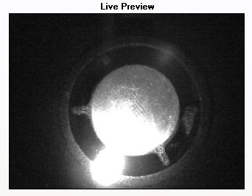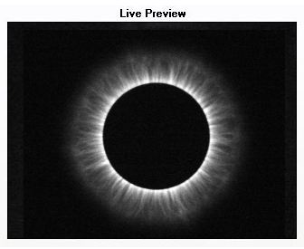
Figure 2: Calibration Probe Figure 3: Energized Image
Verified Not Verified Non-Conformance Ref. No.

Click the Start Duty Cycle button in the Device Actions section. Verify that the Live Preview window alternates repetitively between energized images and the image of the calibration probe.
Save all image files to a cd and attach them to the final report for record keeping.
- Attachments
N/A

Document Revision History
Version Number: | Description of Change | Date: | Updated by:
000 | New Document | 5/15/12 | A. Mason

